

Did you enjoy today’s session? Here’s what else you can do…

1. Have your parents register you for next month’s session using the library website:

www.RidgefieldParkPublicLibrary.org

NEXT SESSION is Thursday, July 17, 2014 7pm-9pm

*It’s where we’ll be posting about all the cool stuff we do at CoderDojo!*



1. Have your parents

Ridgefield Park CoderDojo

1. Spread the word to all your friends! They may want to join our club, too!
2. Keep practicing what you’ve learned today. Here are some websites to check out:

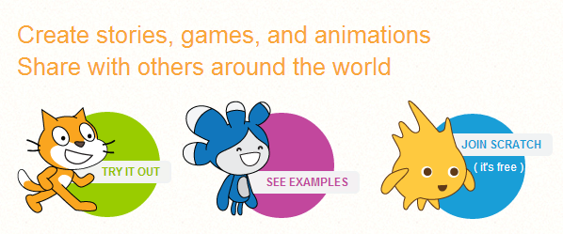[www.Code.org/learn](http://www.Code.org/learn) <http://scratch.mit.edu/>

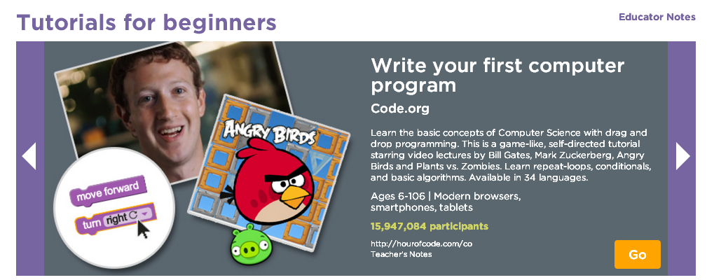

We hope to see you next month… Stay cool and keep on CODING!!!

Champion1 ([champ1 at gmail.com](mailto:ARNIEforte@gmail.com))

Champion2 ([champ 2 at gmail.com](mailto:anabelleforte@alum.rpi.edu))